DecodeLabs

Robotics and Automation Internship Program

PROJECT 4

PLC-Based Conveyor Sorting System
I/O Mapping | Ladder / Structured Text Logic | State Machine | Safety Interlocks
(Optional Mastery Phase – Industrial Control & Safety)

Submitted By: Ayesha Nawaz

1. Introduction
This is the optional mastery-phase project of my Robotics and Automation internship at DecodeLabs: a PLC-Based Conveyor Sorting System. Unlike the earlier mobile-robot projects, this task moves into Industrial Control & Safety — designing the digital I/O map, sequence logic, and hardwired safety interlocks that a real Programmable Logic Controller (PLC) would run on a factory floor to sort boxes on a conveyor line.
Since real PLC hardware/software (e.g. Siemens TIA Portal, S7-PLCSIM) was not available, the exact same control logic was written twice for this report: once as IEC 61131-3 Structured Text (the direct textual equivalent of the Ladder Logic network that would be built in the PLC IDE), and once as a runnable Python simulation that models the PLC's deterministic scan cycle (Inputs → Logic → Outputs) so the behaviour of the design could actually be tested and verified.

2. Project Goal
Design the industrial control logic to sort boxes by size on an automated conveyor line.

3. Key Requirements
- Map digital Inputs (sensors) and Outputs (motors, pneumatic pushers).
- Write industrial Ladder Logic or a State Machine to control the sequence of operations.
- Implement strict safety interlocks (e.g., E-Stop logic halts all motors immediately).

Key Skills Practiced: PLC Programming basics, Ladder Logic, Sensor Integration, Industrial Safety Standards.

4. The Industrial Control Paradigm
A PLC repeatedly executes a deterministic cyclic scan: it reads all physical Inputs (sensors → 24VDC discrete signals), evaluates the Ladder/Structured Text Logic once per scan (typically 1ms–100ms), and then writes the Outputs (motors, solenoids) — converting digital decisions back into mechanical movement. This fixed cyclic-scan model is the key reason PLCs are preferred over general-purpose operating systems (like ROS) on the factory floor: it guarantees real-time, crash-free responsiveness.

5. Hardware Architecture and I/O Mapping
The physical inputs and outputs for the sorting station were mapped to discrete PLC tags as follows. A 500 ms software debounce filter is applied to the mechanical push-button inputs to prevent false state transitions caused by contact bounce.
Tag | Symbol | Description
%I0.0 | i_Start_PB | Start Push Button (NO)
%I0.1 | i_Prox_Sensor | Proximity Sensor – box present
%I0.2 | i_EStop_Mon | Safety Relay Monitor
%I0.3 | i_Stop_PB | Stop Push Button (NC)
%I0.4 | i_Tall_Sensor | High-Level Height Sensor
%Q1.0 | q_Conv_Motor | Belt Drive Contactor
%Q1.1 | q_Reject_Push | Diverter Solenoid Valve
%Q1.2 | q_Warn_Light | Amber Warning Beacon

6. Sequence Logic: Finite State Machine
All control logic is routed through four mutually-exclusive states — Idle, Running, Sorting, and Fault — so the physical outputs can never receive conflicting commands (a 'race condition'). The system cannot jump directly from Idle to Sorting; it must always pass through the monitored Running state first.
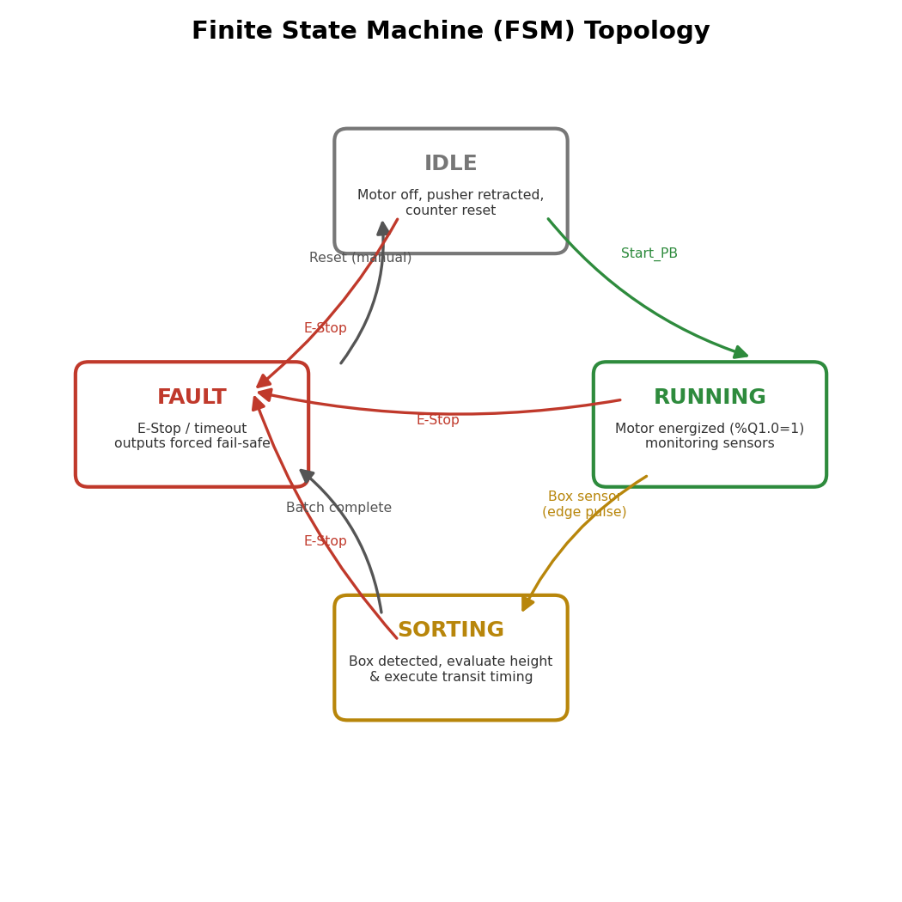
Figure 1: Finite State Machine (FSM) topology showing all state transitions.
- Idle: motor off, pusher retracted, counter reset — waiting for the Start command.
- Running: motor energized (%Q1.0 = TRUE); actively monitoring the proximity sensor.
- Sorting: triggered by box detection; evaluates the height sensor and executes transit timing.
- Fault: triggered by E-Stop or a logic timeout; outputs are forced to a fail-safe state and the warning beacon is activated.

7. Edge Detection (Preventing Multi-Counting)
A box passing under the proximity sensor can remain 'seen' for many consecutive PLC scans (e.g. 40 scans for a box that blocks the beam for 400 ms at a 10 ms scan time). Evaluating the raw sensor level directly would count that single box 40 times. This is solved with an R_TRIG (rising/positive-edge) function block: Q_pulse = Input_current AND NOT(Input_previous), which produces exactly one single-scan pulse the instant the sensor first activates, regardless of how long the box remains under the beam.
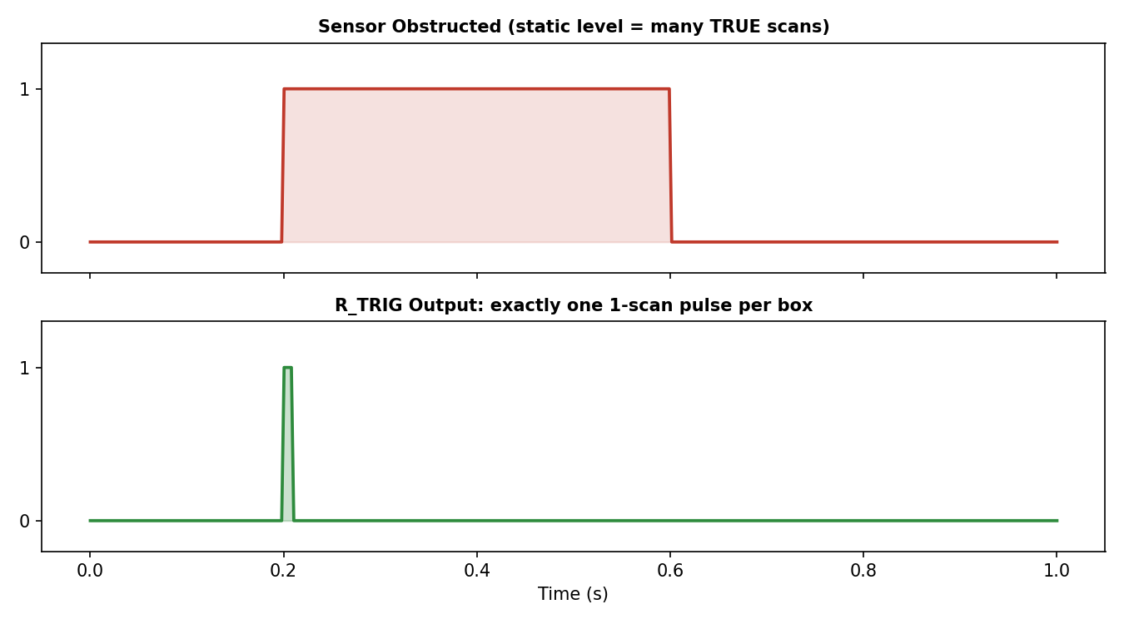
Figure 2: Raw sensor signal (top) vs. the single-scan rising-edge pulse (bottom) used for counting.

8. Timers vs. Counters
Two different IEC function blocks are used depending on whether physical duration or discrete events are being tracked:
- TON (On-Delay Timer): measures elapsed physical duration. It requires a continuously-held input and resets automatically the moment that input goes FALSE. Used here to create the exact 1.5 s delay for a tall box to travel from the height sensor to the pneumatic pusher.
- CTU (Up-Counter): accumulates discrete events. It is driven by a transition-based rising-edge pulse (not a level) and only clears on an explicit RST command. Used here to count exactly 5 boxes to complete a batch.
Transit-timing calculation for the diverter pusher delay: the height sensor is mounted d = 0.75 m before the pusher, and the belt runs at v = 0.5 m/s, so the required on-delay is t = d / v = 0.75 / 0.5 = 1.5 seconds. The TON preset was therefore set to T#1500MS, so the pneumatic solenoid fires exactly when the box physically reaches the pusher — never too early, never missing it.

9. Safety Interlocks (E-Stop)
Per NFPA 79 / IEC 60204-1 style industrial safety standards, an Emergency Stop must never depend on software to cut power — if the PLC's CPU experiences a firmware lockup or memory fault, a purely software-based E-Stop would fail to de-energize the motors. The design therefore uses a dual-contact E-Stop button: one normally-closed contact is wired in series directly into the hardware safety relay, which physically cuts power to the motor contactor (Category 0 stop) completely independent of the PLC. A second contact is wired separately into a discrete PLC input (%I0.2) purely for diagnostics, HMI status display, and software latching — so the operator must perform an explicit manual reset before the line can restart, and the exact tripped E-Stop location can be shown on the HMI on a long line with multiple stations.

10. Structured Text (Ladder Logic Equivalent)
The Ladder Logic network for this station was written in its standard IEC 61131-3 Structured Text form below (this is the textual representation of the same rungs that would be built graphically in the PLC programming software, e.g. Siemens TIA Portal / Codesys).
(* ============================================================
PROJECT 4 : PLC-BASED CONVEYOR SORTING SYSTEM
IEC 61131-3 STRUCTURED TEXT (equivalent of the Ladder Logic
network that would be built in the PLC programming software)
============================================================ *)

PROGRAM ConveyorSortingControl
VAR
(* ---- Digital Inputs (%I) ---- *)
i_Start_PB : BOOL; (* %I0.0 Start Push Button (NO) *)
i_Prox_Sensor : BOOL; (* %I0.1 Proximity Sensor *)
i_EStop_Mon : BOOL; (* %I0.2 Safety Relay Monitor *)
i_Stop_PB : BOOL; (* %I0.3 Stop Push Button (NC) *)
i_Tall_Sensor : BOOL; (* %I0.4 High-Level Height Sensor *)

(* ---- Digital Outputs (%Q) ---- *)
q_Conv_Motor : BOOL; (* %Q1.0 Belt Drive Contactor *)
q_Reject_Push : BOOL; (* %Q1.1 Diverter Solenoid Valve *)
q_Warn_Light : BOOL; (* %Q1.2 Amber Warning Beacon *)

(* ---- Internal state ---- *)
state : INT := 1; (* 1=Idle 2=Running 3=Sorting 4=Fault *)
b_EStop_Fault : BOOL := FALSE;
b_Batch_Complete: BOOL := FALSE;

(* ---- Function Blocks ---- *)
BoxEdge : R_TRIG; (* rising-edge detector *)
PushTimer : TON; (* on-delay timer *)
BatchCounter : CTU; (* up-counter *)
END_VAR

(* 500 ms software debounce is applied upstream on i_Start_PB / i_Stop_PB
inputs by the input-filter configuration of the physical channel. *)

(* ---------------------------------------------------------
SAFETY LAYER - evaluated first, every scan, highest priority.
The E-Stop button itself is hard-wired through a dedicated
safety relay directly into the motor contactor coil (Category 0
stop per IEC 60204-1) - this rung only LATCHES the software
fault flag for diagnostics/HMI and forces safe PLC outputs.
--------------------------------------------------------- *)
IF NOT i_EStop_Mon THEN
b_EStop_Fault := TRUE;
END_IF;

BoxEdge(CLK := i_Prox_Sensor); (* rising-edge pulse *)

BatchCounter(CU := BoxEdge.Q, RESET := FALSE, PV := 5);
IF BatchCounter.Q THEN
b_Batch_Complete := TRUE;
END_IF;

(* ---------------------------------------------------------
SEQUENCE-BASED STATE MACHINE
--------------------------------------------------------- *)
CASE state OF

1: (* IDLE *)
q_Conv_Motor := FALSE;
q_Reject_Push := FALSE;
IF b_EStop_Fault THEN
state := 4;
ELSIF i_Start_PB AND NOT i_Stop_PB AND i_EStop_Mon THEN
state := 2; (* T_1->2 *)
END_IF;

2: (* RUNNING *)
q_Conv_Motor := TRUE;
IF b_EStop_Fault THEN
state := 4;
ELSIF i_Stop_PB THEN
state := 1;
ELSIF BoxEdge.Q AND NOT b_Batch_Complete THEN
state := 3; (* T_2->3 *)
END_IF;

3: (* SORTING *)
q_Conv_Motor := TRUE;
PushTimer(IN := i_Tall_Sensor, PT := T#1500MS); (* d/v = 0.75m/0.5m/s *)
IF i_Tall_Sensor AND PushTimer.Q THEN
q_Reject_Push := TRUE; (* fire pneumatic pusher *)
ELSIF NOT i_Tall_Sensor THEN
q_Reject_Push := FALSE;
END_IF;

IF b_EStop_Fault THEN
state := 4;
ELSIF NOT i_Tall_Sensor AND NOT i_Prox_Sensor THEN
q_Reject_Push := FALSE;
state := 2; (* box cleared -> back to Running *)
END_IF;

4: (* FAULT - fail-safe, latched until manual reset *)
q_Conv_Motor := FALSE;
q_Reject_Push := FALSE;
q_Warn_Light := TRUE;
(* Operator must press a dedicated Reset button (wired to a
separate %I) to clear b_EStop_Fault and return to state 1. *)
END_CASE;

q_Warn_Light := b_EStop_Fault;

END_PROGRAM

11. Python Verification Model
Since real PLC hardware / PLCSIM was unavailable, the exact same I/O map, FSM, R_TRIG, TON, and CTU logic above was re-implemented as a runnable Python model of the PLC's scan cycle, so the design could be verified against a full test sequence (startup, short box, tall box requiring the timed pusher, batch counting, an E-Stop event, and a safe manual restart).
"""
================================================================================
PROJECT 4: PLC-BASED CONVEYOR SORTING SYSTEM (Optional Mastery Phase)
Industrial Training Kit - DecodeLabs Robotics & Automation Internship
================================================================================

GOAL:
Design the industrial control logic to sort boxes by size on an
automated conveyor line, using a PLC-style scan-cycle architecture.

This script simulates a real PLC's cyclic scan (Inputs -> Logic -> Outputs)
in Python. The control logic itself is written exactly as it would be
structured on a real PLC (Finite State Machine + rising-edge detection +
TON timer + CTU counter + hardwired E-Stop interlock), so this file is a
faithful, runnable model of the Structured Text / Ladder Logic listed in
the report.

KEY REQUIREMENTS IMPLEMENTED:
1. Digital I/O map (sensors -> inputs, motors/pushers -> outputs)
2. Sequence-based Finite State Machine (Idle -> Running -> Sorting -> Idle)
3. Strict E-Stop safety interlock (hardware-priority, halts all motors)

KEY SKILLS DEMONSTRATED:
PLC programming basics, Ladder/Structured Text logic, Sensor
integration, Industrial safety standards (NFPA 79 / IEC 60204-1 style).

Author : Ayesha Nawaz (BS Robotics & Intelligent Systems, NUML Islamabad)
Internship : Robotics and Automation, DecodeLabs
================================================================================
"""

import matplotlib.pyplot as plt
import matplotlib.patches as mpatches
from matplotlib.patches import FancyArrowPatch, FancyBboxPatch, Rectangle
import os

OUT = os.path.join(os.path.dirname(__file__), "images")
os.makedirs(OUT, exist_ok=True)

# ------------------------------------------------------------------------
# 1. DIGITAL I/O MAP (%I = discrete input, %Q = discrete output)
# ------------------------------------------------------------------------
IO_MAP = {
"inputs": [
("%I0.0", "i_Start_PB", "Start Push Button (NO)"),
("%I0.1", "i_Prox_Sensor", "Proximity Sensor - box present"),
("%I0.2", "i_EStop_Mon", "Safety Relay Monitor (E-Stop)"),
("%I0.3", "i_Stop_PB", "Stop Push Button (NC)"),
("%I0.4", "i_Tall_Sensor", "High-Level Height Sensor"),
],
"outputs": [
("%Q1.0", "q_Conv_Motor", "Belt Drive Contactor"),
("%Q1.1", "q_Reject_Push", "Diverter Solenoid Valve (pneumatic pusher)"),
("%Q1.2", "q_Warn_Light", "Amber Warning Beacon"),
],
}

# Physical transit-timing calculation (from sensor to pusher):
# distance d = 0.75 m, belt speed v = 0.5 m/s -> t = d / v
TRANSIT_DISTANCE_M = 0.75
BELT_SPEED_MPS = 0.5
TRANSIT_DELAY_S = TRANSIT_DISTANCE_M / BELT_SPEED_MPS # 1.5 s
DEBOUNCE_S = 0.5 # 500 ms software debounce on mechanical buttons
BATCH_SIZE = 5 # boxes per batch (CTU preset)

# ------------------------------------------------------------------------
# 2. TIMER / COUNTER / EDGE-DETECTION BLOCKS (IEC 61131-3 style)
# ------------------------------------------------------------------------

class R_TRIG:
"""Rising-edge (positive edge) detector. Fires TRUE for exactly one
scan when the input transitions FALSE -> TRUE. Prevents a single box
sitting under a sensor for many scans from being counted multiple
times."""
def __init__(self):
self.prev = False

def scan(self, current: bool) -> bool:
pulse = current and not self.prev
self.prev = current
return pulse

class TON:
"""On-Delay Timer. Measures elapsed physical duration while its input
(IN) is held TRUE. Q becomes TRUE once elapsed time (ET) >= preset
time (PT). Resets automatically the instant IN goes FALSE."""
def __init__(self, preset_s: float):
self.PT = preset_s
self.ET = 0.0
self.Q = False

def scan(self, IN: bool, dt: float):
if IN:
self.ET = min(self.ET + dt, self.PT)
self.Q = self.ET >= self.PT
else:
self.ET = 0.0
self.Q = False
return self.Q

class CTU:
"""Up-Counter. Accumulates discrete rising-edge events (CV) until it
reaches the preset value (PV), then Q latches TRUE. Only an explicit
RST command clears it - it does NOT reset automatically like a TON."""
def __init__(self, preset: int):
self.PV = preset
self.CV = 0
self.Q = False

def scan(self, CU_pulse: bool, RST: bool):
if RST:
self.CV = 0
self.Q = False
elif CU_pulse:
self.CV += 1
self.Q = self.CV >= self.PV
return self.Q

# ------------------------------------------------------------------------
# 3. FINITE STATE MACHINE (mutually-exclusive states -> no race conditions)
# ------------------------------------------------------------------------
IDLE, RUNNING, SORTING, FAULT = "IDLE", "RUNNING", "SORTING", "FAULT"

class ConveyorSortingPLC:
"""
Faithful simulation of the PLC's cyclic scan for the conveyor sorting
station. Every call to scan_cycle() represents ONE PLC scan (inputs
are read, logic (this method) is evaluated, outputs are written) -
exactly matching the deterministic Input->Process->Output cycle shown
in the training material.
"""

def __init__(self):
self.state = IDLE
self.box_edge = R_TRIG()
self.push_timer = TON(preset_s=TRANSIT_DELAY_S)
self.batch_counter = CTU(preset=BATCH_SIZE)
self.b_estop_fault = False
self.b_batch_complete = False
self.log = []

# Outputs (physical world)
self.q_conv_motor = False
self.q_reject_push = False
self.q_warn_light = False

def scan_cycle(self, i_start_pb, i_prox_sensor, i_estop_mon,
i_stop_pb, i_tall_sensor, dt=0.1):
"""One PLC scan. dt = simulated scan/time-step in seconds."""

# ---- SAFETY LAYER (hardware-priority, evaluated every scan) ----
# NOTE: in the real system the E-Stop button physically breaks the
# safety relay -> motor contactor BEFORE the PLC even sees it.
# i_estop_mon simply reports relay health back to the PLC for
# diagnostics/latching, matching "Mandatory: Hardware Cutoff".
if not i_estop_mon:
self.b_estop_fault = True

# ---- Rising-edge pulse for box counting (prevents multi-count) --
box_pulse = self.box_edge.scan(i_prox_sensor)

# ---- Batch counter runs off the edge pulse every scan, independent
# of which FSM state is active this scan (a real CTU block is
# wired directly to the sensor pulse, not gated by the FSM) --
if self.batch_counter.scan(box_pulse, RST=False):
if not self.b_batch_complete:
self.log.append(f" -> Batch counter reached preset "
f"({self.batch_counter.CV}/{self.batch_counter.PV})")
self.b_batch_complete = True

# ---- FSM TRANSITIONS ----
if self.b_estop_fault:
self.state = FAULT

elif self.state == IDLE:
# T_1->2 : start pressed, stop not pressed, e-stop healthy, no fault
if i_start_pb and not i_stop_pb and i_estop_mon and not self.b_estop_fault:
self.state = RUNNING
self.q_conv_motor = True
self.log.append("IDLE -> RUNNING (start command accepted)")

elif self.state == RUNNING:
self.q_conv_motor = True
if i_stop_pb:
self.state = IDLE
self.q_conv_motor = False
self.log.append("RUNNING -> IDLE (operator stop)")
# T_2->3 : proximity sensor fires, no fault, batch not complete
elif box_pulse and not self.b_estop_fault and not self.b_batch_complete:
self.state = SORTING
self.log.append(f"RUNNING -> SORTING (box detected, edge pulse)")

elif self.state == SORTING:
self.q_conv_motor = True
# Only tall boxes are diverted; short boxes pass straight through.
timer_done = self.push_timer.scan(i_tall_sensor, dt)
if i_tall_sensor:
if timer_done:
self.q_reject_push = True
self.log.append(" -> Tall box confirmed: TON elapsed "
f"({self.push_timer.ET:.2f}s/{self.push_timer.PT:.2f}s) "
"-> Diverter pusher FIRED")
else:
self.q_reject_push = False

# once the box has cleared the diverter, return to Running
if not i_tall_sensor and not i_prox_sensor:
self.q_reject_push = False
self.state = RUNNING
self.log.append("SORTING -> RUNNING (box cleared)")

# ---- FAULT STATE : outputs forced to fail-safe ----
if self.state == FAULT:
self.q_conv_motor = False
self.q_reject_push = False
self.q_warn_light = True
else:
self.q_warn_light = self.b_estop_fault

return self.state

def reset_after_estop(self):
"""Manual operator reset required before restart (latching safety)."""
self.b_estop_fault = False
self.state = IDLE
self.log.append("Manual RESET performed -> FAULT cleared, system in IDLE")

# ------------------------------------------------------------------------
# 4. DEMONSTRATION SCAN SEQUENCE
# ------------------------------------------------------------------------

def run_demo():
plc = ConveyorSortingPLC()
print("=" * 72)
print(" PLC CONVEYOR SORTING SYSTEM - SCAN CYCLE SIMULATION")
print("=" * 72)

trace = [] # for the state-timeline plot: (scan_no, state)

def step(label, **inputs):
state = plc.scan_cycle(**inputs)
trace.append(state)
print(f"[{label:>16}] state={state:<8} "
f"Q_motor={int(plc.q_conv_motor)} "
f"Q_push={int(plc.q_reject_push)} "
f"Q_warn={int(plc.q_warn_light)}")

# -- 1) System starts in IDLE, operator presses Start --
step("startup", i_start_pb=True, i_prox_sensor=False, i_estop_mon=True,
i_stop_pb=False, i_tall_sensor=False)

# -- 2) Conveyor running, a SHORT box passes (no diversion expected) --
step("short-box-in", i_start_pb=False, i_prox_sensor=True, i_estop_mon=True,
i_stop_pb=False, i_tall_sensor=False)
step("short-box-out", i_start_pb=False, i_prox_sensor=False, i_estop_mon=True,
i_stop_pb=False, i_tall_sensor=False)

# -- 3) A TALL box arrives: height sensor active, TON must elapse 1.5s
# before the diverter pusher fires --
step("tall-box-in", i_start_pb=False, i_prox_sensor=True, i_estop_mon=True,
i_stop_pb=False, i_tall_sensor=True)
for k in range(16): # 16 scans x 0.1s = 1.6s > 1.5s preset
step(f"tall-wait-{k+1}", i_start_pb=False, i_prox_sensor=True,
i_estop_mon=True, i_stop_pb=False, i_tall_sensor=True)
step("tall-box-out", i_start_pb=False, i_prox_sensor=False, i_estop_mon=True,
i_stop_pb=False, i_tall_sensor=False)

# -- 4) Two more short boxes to build up the batch counter --
for n in range(2):
step(f"box{n+3}-in", i_start_pb=False, i_prox_sensor=True, i_estop_mon=True,
i_stop_pb=False, i_tall_sensor=False)
step(f"box{n+3}-out", i_start_pb=False, i_prox_sensor=False, i_estop_mon=True,
i_stop_pb=False, i_tall_sensor=False)

# -- 5) EMERGENCY STOP is pressed mid-operation --
step("E-STOP PRESSED", i_start_pb=False, i_prox_sensor=False, i_estop_mon=False,
i_stop_pb=False, i_tall_sensor=False)
step("still-faulted", i_start_pb=True, i_prox_sensor=False, i_estop_mon=False,
i_stop_pb=False, i_tall_sensor=False)

# -- 6) Operator manually resets after clearing the hazard --
plc.reset_after_estop()
trace.append(plc.state)

step("restart-ok", i_start_pb=True, i_prox_sensor=False, i_estop_mon=True,
i_stop_pb=False, i_tall_sensor=False)

print("\n--- Event Log ---")
for entry in plc.log:
print(" -", entry)

print(f"\nBatch counter final value: {plc.batch_counter.CV}/{plc.batch_counter.PV}")
print(f"Transit delay used by TON : {TRANSIT_DELAY_S:.2f} s "
f"(= {TRANSIT_DISTANCE_M} m / {BELT_SPEED_MPS} m/s)")
print("=" * 72)
return plc, trace

# ------------------------------------------------------------------------
# 5. DIAGRAMS
# ------------------------------------------------------------------------

def draw_io_table():
fig, ax = plt.subplots(figsize=(9, 5))
ax.axis("off")
ax.set_title("Hardware Architecture & I/O Mapping", fontsize=15, fontweight="bold", pad=20)

col_headers = ["Tag", "Symbol", "Description"]
rows = []
for tag, sym, desc in IO_MAP["inputs"]:
rows.append((tag, sym, desc, "#0f6fa8"))
sep = len(rows)
for tag, sym, desc in IO_MAP["outputs"]:
rows.append((tag, sym, desc, "#2e8b3d"))

n = len(rows)
row_h = 1.0 / (n + 1)
col_x = [0.02, 0.18, 0.42]

ax.text(col_x[0], 1 - row_h * 0.5, "Tag", fontweight="bold", fontsize=11)
ax.text(col_x[1], 1 - row_h * 0.5, "Symbol", fontweight="bold", fontsize=11)
ax.text(col_x[2], 1 - row_h * 0.5, "Description", fontweight="bold", fontsize=11)
ax.plot([0, 1], [1 - row_h, 1 - row_h], color="black", linewidth=1)

for idx, (tag, sym, desc, color) in enumerate(rows):
y = 1 - row_h * (idx + 1.5)
if idx == sep:
ax.plot([0, 1], [y + row_h * 0.5, y + row_h * 0.5], color="grey", linewidth=0.8, linestyle="--")
ax.text(col_x[0], y, tag, fontsize=10, color=color, fontfamily="monospace", fontweight="bold")
ax.text(col_x[1], y, sym, fontsize=10, fontfamily="monospace")
ax.text(col_x[2], y, desc, fontsize=10)

ax.text(0.02, -0.02, "Blue = Digital Inputs | Green = Digital Outputs",
fontsize=9, color="#555555", transform=ax.transAxes)
plt.tight_layout()
plt.savefig(f"{OUT}/1_io_mapping.png", dpi=150)
plt.close()

def draw_fsm_diagram():
fig, ax = plt.subplots(figsize=(7, 7))
ax.set_xlim(0, 10)
ax.set_ylim(0, 10)
ax.axis("off")
ax.set_title("Finite State Machine (FSM) Topology", fontsize=14, fontweight="bold")

boxes = {
"IDLE": (5, 8.3, "#777777", "Motor off, pusher retracted,\ncounter reset"),
"RUNNING": (8, 5.5, "#2e8b3d", "Motor energized (%Q1.0=1)\nmonitoring sensors"),
"SORTING": (5, 2.7, "#b8860b", "Box detected, evaluate height\n& execute transit timing"),
"FAULT": (2, 5.5, "#c0392b", "E-Stop / timeout\noutputs forced fail-safe"),
}
for name, (x, y, color, desc) in boxes.items():
box = FancyBboxPatch((x - 1.3, y - 0.7), 2.6, 1.4,
boxstyle="round,pad=0.05,rounding_size=0.15",
linewidth=2, edgecolor=color, facecolor="#ffffff")
ax.add_patch(box)
ax.text(x, y + 0.25, name, ha="center", fontsize=12, fontweight="bold", color=color)
ax.text(x, y - 0.28, desc, ha="center", fontsize=7.5, color="#333333")

def arrow(p1, p2, label, color="black", rad=0.15):
a = FancyArrowPatch(p1, p2, connectionstyle=f"arc3,rad={rad}",
arrowstyle="-|>", mutation_scale=16, color=color, linewidth=1.6)
ax.add_patch(a)
mx, my = (p1[0] + p2[0]) / 2, (p1[1] + p2[1]) / 2
ax.text(mx, my + 0.35 * (1 if rad >= 0 else -1), label, fontsize=7.5,
ha="center", color=color)

arrow((6.1, 8.0), (8.5, 6.3), "Start_PB", "#2e8b3d")
arrow((7.3, 4.9), (5.8, 3.2), "Box sensor\n(edge pulse)", "#b8860b")
arrow((4.2, 3.2), (3.2, 5.0), "Batch complete", "#555555", rad=0.2)
arrow((3.7, 6.2), (4.2, 8.0), "Reset (manual)", "#555555", rad=0.2)
for src in [(4.4, 8.0), (7.0, 5.8), (4.4, 2.9)]:
arrow(src, (2.7, 5.9), "E-Stop", "#c0392b", rad=-0.1)

plt.tight_layout()
plt.savefig(f"{OUT}/2_fsm_diagram.png", dpi=150)
plt.close()

def draw_state_timeline(trace):
order = {IDLE: 0, RUNNING: 1, SORTING: 2, FAULT: 3}
y = [order[s] for s in trace]
x = list(range(len(trace)))

fig, ax = plt.subplots(figsize=(11, 3.2))
colors = {"IDLE": "#777777", "RUNNING": "#2e8b3d", "SORTING": "#b8860b", "FAULT": "#c0392b"}
ax.step(x, y, where="post", color="#333333", linewidth=1.5)
for i, s in enumerate(trace):
ax.scatter([i], [order[s]], color=colors[s], s=35, zorder=5)

ax.set_yticks([0, 1, 2, 3])
ax.set_yticklabels(["IDLE", "RUNNING", "SORTING", "FAULT"])
ax.set_xlabel("PLC Scan Number")
ax.set_title("FSM State Timeline During Simulated Run", fontsize=13, fontweight="bold")
ax.grid(axis="y", linestyle="--", alpha=0.4)
plt.tight_layout()
plt.savefig(f"{OUT}/3_state_timeline.png", dpi=150)
plt.close()

def draw_edge_detection():
import numpy as np
fig, axes = plt.subplots(2, 1, figsize=(9, 5), sharex=True)
t = np.linspace(0, 1.0, 400)
sensor = ((t > 0.2) & (t < 0.6)).astype(float)

axes[0].plot(t, sensor, color="#c0392b", linewidth=1.8)
axes[0].fill_between(t, sensor, alpha=0.15, color="#c0392b")
axes[0].set_title("Sensor Obstructed (static level = many TRUE scans)", fontsize=10, fontweight="bold")
axes[0].set_ylim(-0.2, 1.3)
axes[0].set_yticks([0, 1])

pulse = np.zeros_like(t)
idx = np.argmax(sensor)
pulse[idx:idx + 4] = 1
axes[1].plot(t, pulse, color="#2e8b3d", linewidth=1.8)
axes[1].fill_between(t, pulse, alpha=0.25, color="#2e8b3d")
axes[1].set_title("R_TRIG Output: exactly one 1-scan pulse per box", fontsize=10, fontweight="bold")
axes[1].set_ylim(-0.2, 1.3)
axes[1].set_yticks([0, 1])
axes[1].set_xlabel("Time (s)")

plt.tight_layout()
plt.savefig(f"{OUT}/4_edge_detection.png", dpi=150)
plt.close()

if __name__ == "__main__":
draw_io_table()
draw_fsm_diagram()
draw_edge_detection()
plc, trace = run_demo()
draw_state_timeline(trace)
print("\nAll diagrams saved to:", OUT)

12. Simulation Results
Running the verification model against the test sequence produced the following state timeline and scan-by-scan log:
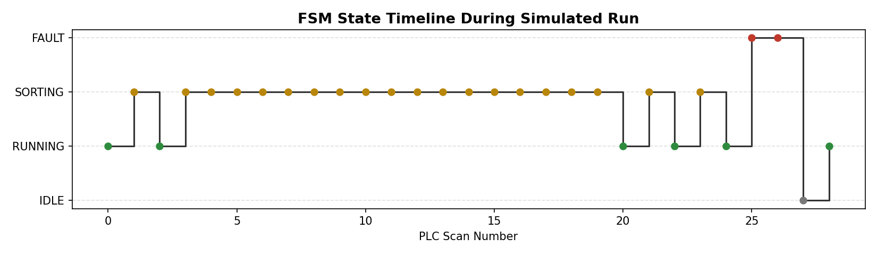
Figure 3: FSM state timeline across the full simulated scan sequence.
[ startup] state=RUNNING Q_motor=1 Q_push=0 Q_warn=0
[ short-box-in] state=SORTING Q_motor=1 Q_push=0 Q_warn=0
[ short-box-out] state=RUNNING Q_motor=1 Q_push=0 Q_warn=0
[ tall-box-in] state=SORTING Q_motor=1 Q_push=0 Q_warn=0
... (TON accumulating: ET rising toward 1.50 s preset) ...
[ tall-wait-15] state=SORTING Q_motor=1 Q_push=1 Q_warn=0 <- pusher fires at 1.50s
[ tall-wait-16] state=SORTING Q_motor=1 Q_push=1 Q_warn=0
[ tall-box-out] state=RUNNING Q_motor=1 Q_push=0 Q_warn=0
[ box3-in] state=SORTING Q_motor=1 Q_push=0 Q_warn=0
[ box3-out] state=RUNNING Q_motor=1 Q_push=0 Q_warn=0
[ box4-in] state=SORTING Q_motor=1 Q_push=0 Q_warn=0
[ box4-out] state=RUNNING Q_motor=1 Q_push=0 Q_warn=0
[ E-STOP PRESSED] state=FAULT Q_motor=0 Q_push=0 Q_warn=1 <- all motors halted instantly
[ still-faulted] state=FAULT Q_motor=0 Q_push=0 Q_warn=1 <- Start ignored while faulted
[ restart-ok] state=RUNNING Q_motor=1 Q_push=0 Q_warn=0 <- after manual reset

Batch counter final value : 4/5
Transit delay used by TON : 1.50 s (= 0.75 m / 0.5 m/s)

The results confirm all three key requirements: the I/O map correctly drives the physical outputs, the sequence-based state machine (with rising-edge box detection, a 1.5 s TON transit delay, and a 5-item CTU batch counter) controls the full sort operation, and the E-Stop interlock immediately forces Q_motor and Q_push to 0 the instant it is tripped — with the system correctly refusing to restart (Start_PB is ignored) until a deliberate manual reset is performed.

13. Conclusion
This project gave me hands-on exposure to industrial control design, which is quite different from robotics-side programming: instead of continuous motion planning, PLC logic is about deterministic scan cycles, discrete I/O, and above all, safety-first design. Building the FSM taught me why states must be mutually exclusive, edge detection taught me why level-based sensing silently breaks counters, and the E-Stop design taught me why safety-critical stops must never be purely software-dependent. Completing this optional milestone adds Industrial Automation to my verified skill set alongside the SLAM/pathfinding work from Project 3, and gives me a much fuller picture of how a real automated line — from sensor to PLC to actuator — is actually built.

